 Software Project Management Report

for

Stocks Trend Prediction

Version 1.0

Prepared by

|  |  |  |
| --- | --- | --- |
| Hassan Ahmed Khan | 201907008 | hassanahmedkhan2018@gmail.com |

|  |  |
| --- | --- |
| Internal :  External: | Engr. Kashif Jamil  - |
| Discipline: | BS – Software Engineering |
|  |  |
|  |  |
|  | |

Table of Contents

**1 INTRODUCTION……………………………………………………………………………78**

* 1. Project Overview…………………………………………………………………….78
     1. Tab 1……………………………………………………………………..78
     2. Tab 2……………………………………………………………………..76
     3. Tab 3……………………………………………………………………..76
     4. Tab 4……………………………………………………………………..77

1.2 Project Deliverables………………………………………………………………….77

**2 PROJECT ORGANIZATIONS……………………………………………………………..77**

2.1 Software Process Model……………………………………………………………..77

2.2 Roles and Responsibilities…………………………………………………………...79

2.3 Tools and Techniques………………………………………………………………..79

**3 PROJECT MANAGEMENT PLAN………………………………………………………...79**

3.1 Description…………………………………………………………………………...79

3.2 Deliverables and Milestones…………………………………………………………79

3.3 Resources Needed……………………………………………………………………80

3.3.1 Software …………………………………………………………………...80

3.3.2 Hardware …………………………………………………………………..80

3.4 Dependencies and Constraints……………………………………………………….80

3.5 Risks and Contingencies……………………………………………………………..80

3.6 UML diagrams……………………………………………………………………….81

3.6.1 Use Case Diagram………………………………………………………….81

3.6.2 Data Flow Diagram………………………………………………………...82

1. **INTRODUCTION**
   1. **Project Overview**

The Stocks Prediction System is a software project designed to analyze historical stock market data and predict future market trends with a high degree of accuracy. The system will use machine learning algorithms and deep learning techniques to analyze large datasets, identifying patterns and trends that can be used to forecast stock prices.

* + 1. **Project Objectives**

The primary objective of the Stocks Prediction System is to create a robust, accurate and reliable tool that can be used by traders and investors to make informed decisions about stock market investments. The system will also be used to help financial analysts and institutions to better understand market trends and forecast future movements.

* + 1. **Project Scope**

The scope of the project includes the development of a web-based application that will allow users to access the prediction system from anywhere with an internet connection. The system will be designed to accept user input, such as specific stocks or timeframes, and generate predictions based on historical data and machine learning algorithms.

* + 1. **Project Timeline**

The project will be completed in 7 months, with the following key milestones:

* Requirements gathering and analysis - 1 month
* Design and development of the software - 4 months
* Testing and quality assurance - 1 month
* User manual creation and final software product - 1 month
  + 1. **Project Risk**

The following risks have been identified for the project:

* Data Security Risks
* Data Availability and Quality Risks
* Technical Risks
* Project Scope
* Stakeholder Communication Risk
  1. **Project Deliverables**

The purpose of the project is to design and implement a Stocks trend prediction using CNN-LSTM, FbProphet etc. The project deliverables are as shown below:

* Project Plan
* Project Design Document
* Test Plan
* Test Report
* Final Report
* Product

1. **PROJECT ORGANIZATIONS**

**2.1 Software Process Model**

Developing a system requires involves not only code writing but also many other activities such as requirement gathering, document writing, testing and others. System development is not an easy task as all the activities have to be done in a well-planned manner. Hence, the development methodologies are guidelines or blueprint to develop the system effectively and efficiently.

**Prototype Model to be applied here.**

The prototype model requires the involvement of users or clients in the early phases, such as the requirement gathering phase and design phase, as this can help to develop the best design before implementation. The prototype model is suitable for projects with unclear requirements as clients can add the requirements during the design phase. Since the prototype model will keep building the prototype until the prototype accepted by users and customers, it is best to be used in the projects that have less understanding of specifications so that the development team can alter the requirements from time to time.

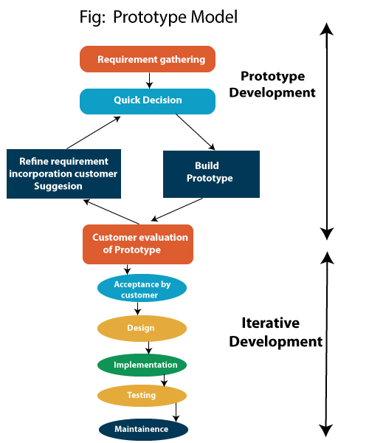

**2.2** **Roles and Responsibilities**

As a solo project executor, only developer is responsible for arranging the tasks, managing the whole project and submitting the deliverables.

**2.3** **Tools and Techniques**

Development Tools:

* Python
* Anaconda Navigator
* Visual Studio
* Streamlit
* Jupyter Noteboo

1. **PROJECT MANAGEMENT PLAN**
   1. **Description**

A project management plan is a collection of baselines and subsidiary plans that include:

* Baselines for scope, schedule, and cost
* Management plans for scope, schedule, cost, quality, human resources, communications, risk, and procurement
* Requirement management plan
* Change management plan
* Configuration management plan
* Process improvement plan
  1. **Deliverables and Milestones**

|  |  |  |
| --- | --- | --- |
| **Milestone** | **Description** | **Due Date** |
| Requirements Specification Document | Document outlining the functional and non-functional requirements of the system | End of Month 1 |
| Design documents | Technical specifications and system design documentation | End of Month 2 |
| Prototype | A functional prototype of the system that can be used for testing and validation | End of Month 3 |
| Testing and Quality Assurance Plan | Plan outlining the testing and quality assurance processes to be used for the project | End of Month 4 |
| Final Software Product | Completed software product that meets all project requirements and specifications | End of Month 7 |

**3.3 Resources Needed**

**3.3.1 Software**

|  |  |
| --- | --- |
| Operating system: | Windows, Linux & Mac OS |
| IDE: | Jupyter Notebook, Streamlit & Visual Studio |
| Data | .csv file |
| Visualization: | matplotlib, seaborn, pandas etc. |
| Set Server : | Web Server with HTTP |

**3.3.2 Hardware**

|  |  |
| --- | --- |
| Processor : | Intel i5 or above |
| Ram: | Minimum 225MB or more. |
| Hard Disk : | Minimum 2 GB of space |
| Input Device : | Keyboard |
| Output Device : | Screens of Monitor or a Laptop |

**3.4 Dependencies and Constraints**

* Stock analysis is a process followed by traders to evaluate and understand the value of a security or the stock market.
* Stock analysis follow the idea that analysts can create methodologies to select stocks by studying past and present data.
* Generally predictions of stocks help stocks agents to verify the stocks prices.
* User of this software will help him to buy the particular software at their best time.

**3.5 Risks and Contingencies**

* As the project is about the prediction of stocks there is a risk involved in predicting the prices. On every refresh, the prediction module will get minimum amount of error that is mse (mean squared error) & mve (mean valued error).
* Contingency reserve of 20% of the project cost. If there is any cost associated with lack of time, 50% of the total amount is taken into consideration. 25% of the amount will be given to meet contingency factor such as non-availability of raw materials. Rest of the amount is given to meet the unforeseen circumstances.

**3.6 UML diagrams**

**3.6.1 Use Case Diagram**

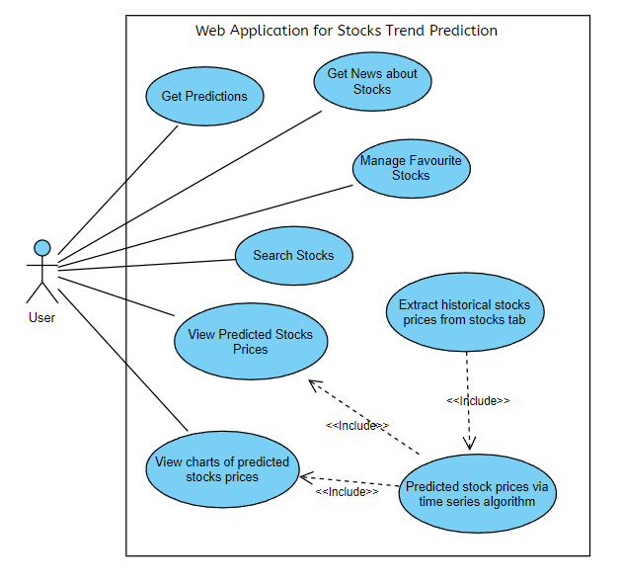

**3.6.2 Data Flow Diagram**

